Microservices with Spring Boot 3 and Spring Cloud

Creating Microservices for account and loan
INPUT:
Loan.java
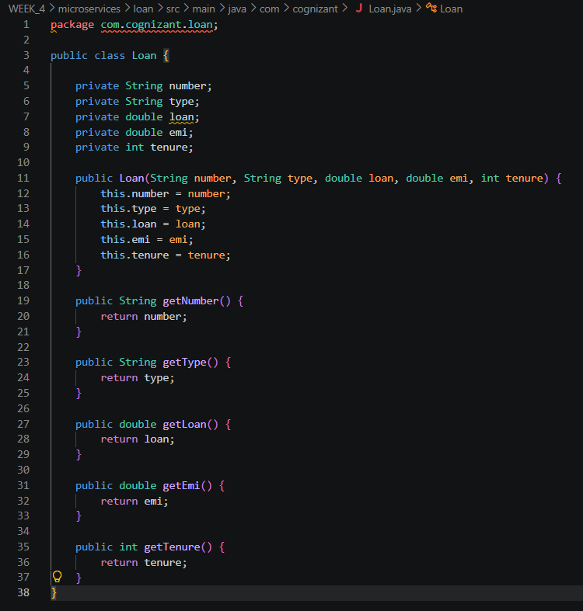
Account.java
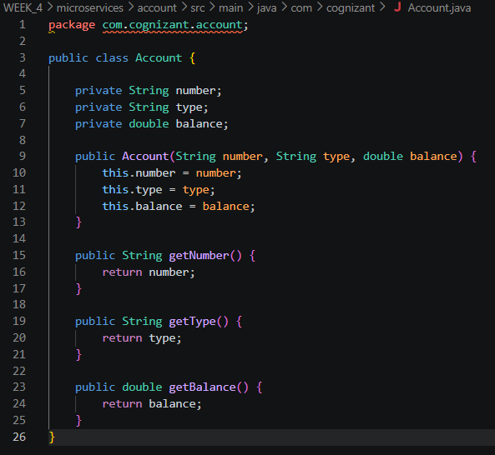
OUTPUT:
http://localhost:8080/accounts/00987987973432
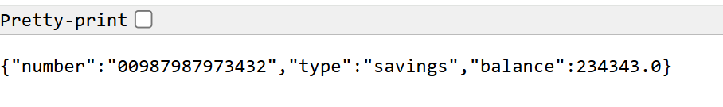
http://localhost:8081/loans/H00987987972342
